A Pragmatic Approach to the Design and Implementation of a Vibrotactile Belt and its Applications
Nathan Edwards, Jacob Rosenthal, Daniel Moberly, Jon Lindsay, Kris Blair, Sreekar Krishna, Troy McDaniel, Sethuraman Panchanathan
Center for Cognitive Ubiquitous Computing (CUbiC)
Department of Computer Science and Engineering, Ira A. Fulton School of Engineering
Arizona State University, Tempe, AZ

Abstract—A human centered pragmatic approach to the design and implementation of a vibrotactile belt is presented in this paper. Based on a) extensive usability feedback we've collected over the past year, and b) a thorough survey of existing design guidelines from the literature, we propose a set of design guidelines for the development of haptic belts that can span seamlessly across various applications. These guidelines cover three important aspects for haptic belts: functionality, performance and usability, which are vital for longitudinal use by end users. Taking a human-centric approach from these design guidelines, we demonstrate the construction of a wirelessly controlled haptic belt design that is versatile, usable and practical. Implementation details of the belt are given, along with a preliminary usability study and a brief review of some of the important application areas of haptic belts. Results from the usability study reveal that participants were very pleased with the proposed haptic belt, and found it to be easy to wear and use.
Keywords-haptic belt; vibrotactile belt; tactile icons; tactons; vibrotactile display; tactile display; vibrotactile wearable; assistive devices; assistive technology

Introduction
Recently, a number of vibrotactile displays have been developed in the form factor of a belt (commonly referred to as a vibrotactile belt, or haptic belt). The exploding growth in research toward this specific form factor can be attributed to the number of important applications that are conceptually possible with a haptic belt, including pedestrian navigation [1][2], spatial orientation [3][4], and generic information communication [5]. Haptic belts are also useful as assistive technology for individuals who are blind, such as for use as a social interaction aid [6][7]. (See Section VI for an overview of various applications.) Further, haptic belts have helped expand our understanding of human haptic perception through providing researchers with tools to study touch [8].
A number of haptic belts have been proposed in the literature (these will be presented in Section III). Typically, haptic belts have been designed for specific applications, such as navigation, limiting their general applicability. Further, while some belts have impressive functionality (e.g., the location of tactors can be adjusted, the dimensions of vibratory signals can be altered, etc.), usability and performance (e.g., limited cumber, robustness, etc.) do not seem to be of much concern, and are typically ignored. In other words, implementations tend to take a technology-centric approach with the goal of demonstrating feasibility of the technology. In contrast, our strategy accounts for the user’s needs and concerns through a human-centric approach [9]. Here, we generalize the scope of our users to include any end-user—both developers (engineers, scientists, etc.) and users who will wear and use the belt on a daily basis. To this end, we take a pragmatic approach to the design and implementation of a haptic belt focusing on modularity, functionality, performance and usability. The flexibility offered by our design, in which tactors can be added, removed or adjusted, and easily reconfigured by software, gives the belt its versatility while providing a platform from which a variety of implementations can be realized and tested.
This work is largely motivated by our previous work [6][7], where we discuss the design of a haptic belt for assisting individuals who are blind during social interactions. The belt consisted of seven tactors equidistantly placed in a semi-circle around the front of the user’s waist. The belt had several shortcomings: the locations of the tactors were fixed; not all vibratory dimensions, including amplitude and frequency, could be changed; and the belt was controlled through wired connections to a computer, limiting user’s movement, and hence, any longitudinal studies. Over the last year, through use of the aforementioned haptic belt, we’ve conducted various experiments related to haptic perception of vibrotactile stimuli. From our interactions with subjects during these experiments, we’ve compiled a wealth of usability feedback. Moreover, during the course of designing many of these experiments, the needs of experiment participants/designers have been noted in terms of desired functionality, performance and usability. From this feedback, along with existing design guidelines for vibrotactile wearables [10][11], we propose a set of design guidelines for haptic belts (Section II) and present a novel haptic belt implementation based on these requirements (Section IV) followed by a preliminary user study (Section V).

design requirements
Our proposed design guidelines are shown in Table I. Primarily, we identify three important design requirements, namely functionality, performance and usability. Lindeman et al. [10] proposed three desirable functionality attributes for wearable vibrotactile displays: expressiveness, scalability and reconfigurability. According to them, a vibrotactile display is expressive when vibrations can be altered in their intensity, timing, and location on the body. To achieve scalability, a vibrotactile display should enable tactors to be easily added or removed without performance degradation. Reconfigurability is related to the adaptability of the belt to various applications and uses; hence, to this end, an application programming interface (API) and adjustable tactor locations, are critical components of reconfigurability. We add a fourth functionality attribute to this list, namely portability, which is influenced by the wearability of a system and its wireless capabilities.
The second set of attributes, grouped under performance requirements, include robustness and rigidity; reliability; long wireless communication range; negligible latency in wireless communication; long battery life; and rechargeable or replaceable batteries. Strong performance characteristics, such as the attributes listed here, are important components toward a practical, usable, versatile haptic belt. The level of performance required with respect to each attribute will depend on the application and context of use. A versatile implementation should concentrate on worst-case scenarios, and make no assumptions about potential levels of satisfactory performance for a given set of applications.
Finally, usability is the third and most important factor to consider during the design of any human-computer interface. We group several attributes under usability, including limited cumber, intuitiveness, and discreetness. Lindeman et al. [10] described limited cumber as an attribute of a wearable system that is easy to take on or off, and does not hinder movement with excessive cabling and bulky components. Extending the scope of this attribute, we add that a wearable haptic belt should be comfortable and unobtrusive [11], ergonomic, lightweight and adaptive to fit different waist sizes. The interactive design of the belt, including programming interfaces, should be intuitive to ensure that the belt is easy to use for all end-users, and powerful enough to be repurposed. Lastly, a haptic belt should be discreet. Belts are a common part of our attire, and naturally discreet, so keeping the design as close as possible to everyday dressing styles will allow broader acceptance among users. Most importantly, tactors should be silent during operation as to avoid distracting others.
TABLE I. Design Requirements
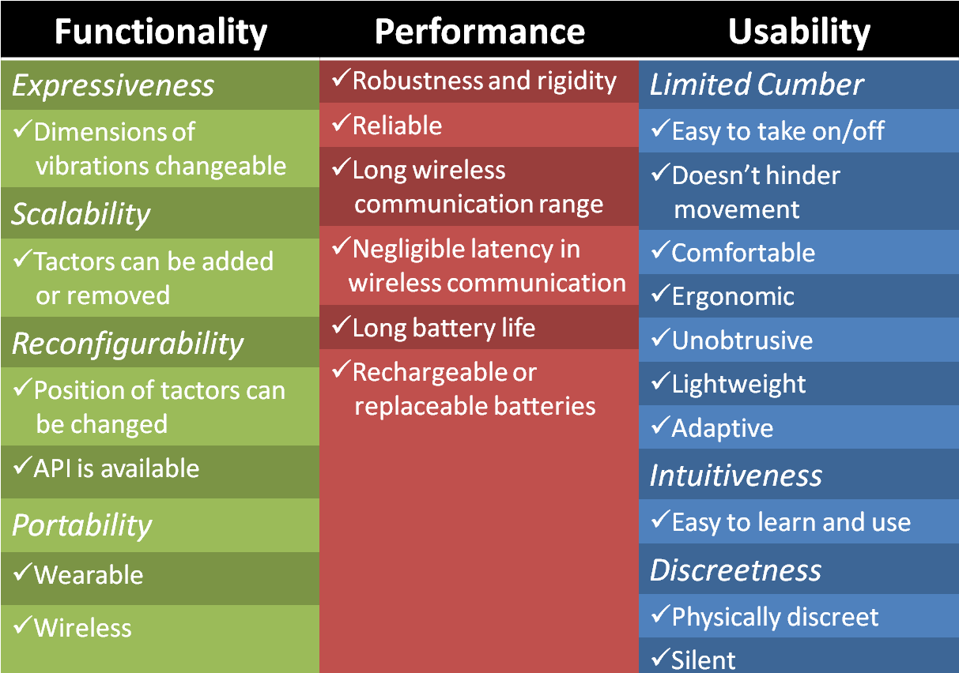

related work
A variety of belt designs have been proposed in the literature. Most of these designs are motivated by a particular application. Furthermore, most of these implementations lack usability and performance studies as the central focus tends to be a proof of concept. In fact, usability and performance are rarely discussed. Implementations often have excessive cabling and bulky modules, while the required robustness and rigidity for real-world use are completely ignored. Through an extensive literature survey, we found over twenty different vibrotactile belts from both academic publications and electronics hobby forums. Due to limited space, Table II presents a sample of seven haptic belts, chosen based on maturity and availability of information regarding design choices and implementation details. Table II provides a comparison of these belts, as well as our own design, based on the functionality design requirements. The attributes are color-coded: attributes for expressiveness are in turquoise, attributes for scalability and reconfigurability are in purple, and attributes for portability are in orange. A checkmark indicates that a feature is available, whereas a blank entry indicates that the feature is either not available or its availability is unknown to the best of our knowledge. Our design takes into account not only the functionality requirements, but also performance and usability, all of which are underestimated by most implementations.

belt design and implementation
Figure 1 shows the specifics of the implementation. The wireless connection between the belt and the computer provides the desired portability and limited cumber upon which the rest of the system is developed. The wireless haptic belt consists of a hierarchical microcontroller design with a main controller (Haptic Belt Controller) for PC or PDA communication and overall system maintenance, and auxiliary controller (Tactor Controller) for monitoring each vibration motor. While the main controller provides the user interface to access the tactors on the belt, the auxiliary controllers ensure fine control of amplitude (perceived level of vibration intensity) and timing of vibration for each motor. This multilayer architecture caters to the four important functional requirements of expressiveness, scalability, reconfigurability and portability. Any number of tactor modules, up to a maximum of 128, can be added to the belt without changing the firmware on the main controller (although we limited our implementation to 16 tactors or less). The functionality of the belt is exposed through an application programming interface, and can be leveraged through a command line (terminal control) or a graphical user interface for belt configuration and activation.
TABLE II. Functionality-wise Comparison of Haptic Belts
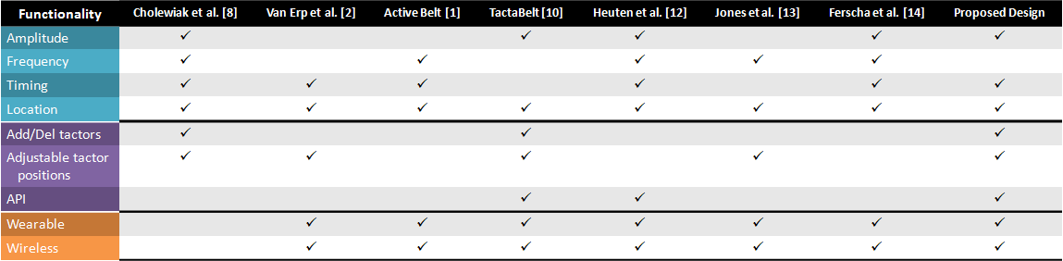

The entire system is powered by a slim 3.7V lithium-ion battery with higher per cell voltage (3.7V) and high power density (100-160 Wh/kg) when compared to Ni-Cd (1.2V at 40–60 Wh/kg) or Ni-Mh (1.2V at 30-80 Wh/Kg) batteries. The power is distributed using two of the haptic belt’s four bus wires. The remaining two bus wires act as the data and clock lines of a standard I²C bus on which all 16 tactor modules listen to the main controller for specific commands on the amplitude and timing of vibration.
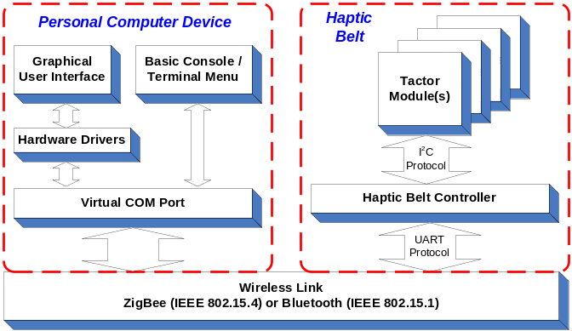 Figure 1. High-level system block diagram.

Hardware

Belt Form Factor
The belt harness and electronic system enclosures, shown in Figure 2, ultimately determine wearability. The belt harness, easily adjustable to any waist size, was constructed from 1.5 inch flat nylon webbing with quick connect acetyl plastic buckles. Likewise, the Serpac model C-2 electronic enclosure with a pocket clip was selected as an inexpensive commercial off-the-shelf (COTS) low-profile enclosure for the tactor modules. The pocket clips and bus connectors allow tactors to be easily repositioned, added or removed. This design was chosen over a Velcro based implementation for several reasons: to achieve better adaptability to different waist sizes; to hold tactors very close to the body during use; and robustness and rigidity for real-world use. Moreover, this design is lightweight, comfortable, silent and physically discreet as the control box can fit inside a pant pocket or attach to the belt and status LEDs can be turned off during use.
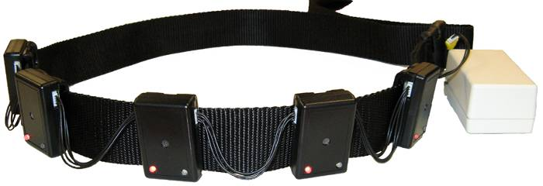
Figure 2. Haptic belt harness and tactor modules.

Tactor Module
The tactor module houses a controller which drives the vibration motor. An ATtiny88 Atmel microcontroller forms the core of the tactor module with a small design footprint and onboard oscillator. The pulse-width modulation (PWM) unit on the controller is used to change the amplitude of vibration (by varying the duty cycle) and also generate different vibrotactile patterns and rhythms. Six pins of the ATtiny88 were configured to read a DIP switch setting that allows automatic configuration of its data communication bus address upon cycling the power. This eliminates the need to reprogram all tactor modules for different applications/uses, thus providing plug-and-play functionality.
The circuit diagram of an individual tactor module is shown in Figure 3. A coin-type shaftless vibration motor, Precision Microdrives 312-101, forms the vibrator with a rotational speed of 150Hz and a nominal vibration of 0.9g. The motor is switched with a low-side NUD3105 MOSFET inductive load driver, which has internal back emf protection built into its circuitry. The use of a MOSFET allows for lower gate current (less than 1mA) and even less leakage current when compared to a BJT transistor. LEDs visible on the outside of the module are provided for debug purposes.
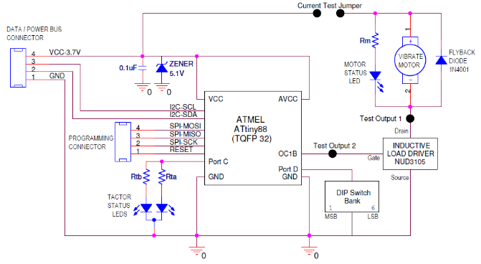
Figure 3. Tactor module schematic.

Main Controller
Since all control and data communication of the haptic belt flows through the main controller, it must handle several mechanisms of communication including UART, Wireless, and I²C data bus communication. The main controller must also have enough on-chip memory to store belt configurations and console debug menus. We chose a specific implementation of the popular Arduino Open Source platform, called Funnel I/O. The board is based on Atmel ATmega168 microcontroller, a fully functional 8-bit controller with 16KB of Flash memory. The Funnel I/O supports all of the capabilities of the ATmega168 with a 1:1 pad to pin ratio for input/output. The board already has a power switch, reset button, status LEDs, lithium ion charging circuitry through a miniUSB connector, battery connection, and headers prewired for a plug-and-play XBee wireless module. The PCB is fairly small in size, which meets our form factor requirements.

Wireless Module
We chose a self-encapsulated COTS wireless module with small form factor and an integrated chip antenna. Digi’s XBee ZNet module was selected given that the Funnel I/O controller board can integrate with it without any additional design and the supported mesh network is forward looking. The XBee is a plug-and-play ZigBee wireless protocol module that fully supports the IEEE 802.15.4 sensor mesh network standard, and offers data transfer rates of 250 kbps with a range of up to 133 feet indoors. Similarly, a self-encapsulated Bluetooth module RN-41 from Roving Networks, using the IEEE 802.15.1 protocol and with similar range to the Xbee, was selected for an alternate wireless interface because of its ubiquitousness and the module was easily modified to fit within the Funnel's Xbee port.

Software

Firmware
The architecture of the haptic belt’s real-time embedded firmware fulfills several purposes. It controls vibration amplitude, timing and location, from which vibrotactile spatio-temporal patterns can be created. Up to five rhythm patterns, four amplitudes and the last in-use mode configuration can be stored for later use. Additionally, the firmware controls all belt logic including inter-module communication including the PC-wireless link, on-chip memory, tactor modules on the data bus, and provides a basic console/terminal menu that allows direct interaction with the belt configuration through a serial communication link (wireless or RS-232).
With only limited memory space (16KB for the ATmega168 or 8KB for the ATtiny88), the firmware architecture had to be carefully engineered to provide the necessary functionality and ease of use while maintaining real-time performance. A simple command set structure similar to Hayes AT commands are used to minimize transmissions on the interconnect bus, and allows the 16 tactor modules to be sequentially switched on or off with a granularity of a few microseconds. The firmware was designed using the C language, and the open-source Arduino and Atmel’s AVR libraries. The firmware provides four primary user modes to create a new belt configuration, query the current configurations, test vibrotactile patterns, and activate “in-use” mode. There are several levels of configuration available that allow users the flexibility of creating different vibrotactile spatio-temporal patterns. The current configuration settings along with all programmed vibrotactile patterns are stored in non-volatile memory to maintain a readiness state and ease of use.

Graphical User Interface
The graphical controls, written using the C# language and .NET components, allow easy configuration of complex vibrotactile rhythm patterns using text inputs and drop-down menu selections (Figure 4). Users can also specify tactor module locations, and query the wireless haptic belt for its current configuration. The software also provides utilities for creating spatio-temporal patterns using specified tactor modules and rhythms.
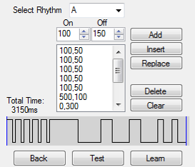
Figure 4. Graphical interface controls for vibrotactile rhythms.

Preliminary usability study
To evaluate the usability of our proposed belt, we conducted a study similar to the evaluation performed by Lindeman et al. [15], which put test subjects in realistic scenarios to test the usability limits of a wearable, tactile display. Four subjects participated in our pilot study. Subjects were asked to perform the following tasks: (1) put on the belt given basic instructions and without the help of the experimenter; (2) stand while wearing the belt; (3) sit while wearing the belt; (4) walk while wearing the belt; (5) jog while wearing the belt; and (6) take off the belt without help from the experimenter. During tasks (2) through (5), subjects had to localize vibrations around their waist. Since our goal was to evaluate usability, as opposed to the spatial acuity of vibrations around the waist, we chose a belt configuration where no training was needed, and near 100% localization accuracy could be achieved under controlled conditions without noise or distractions. In this simulated use condition, we restricted the number of tactors to five, and they were equidistantly placed in a semicircle around the user’s waist such that the leftmost tactor was at the user’s left side, the center tactor was at the navel, and the rightmost tactor at the right side. The main controller module was clipped on the belt. Vibratory pulses had an amplitude of 0.9g (100% magnitude of the motor’s specified nominal vibration or full-on) and a duration of 500ms at 150Hz rotational speed.
For task (1), subjects were told to put on the belt and adjust the tactors such that they matched the aforementioned configuration. After task (1), subjects were asked to rate how easy it was to put on the belt, using a 10-point Likert scale from 1 (difficult) to 10 (easy). Before the remaining tasks, subjects went through a brief familiarization phase to become acquainted with the locations of vibration and the numbering scheme. The experimenter activated tactors #1 through #5, in order, and called out each tactor number to the subjects. This was repeated once for each subject. After the familiarization phase, subjects began testing, i.e., tasks (2) through (5), without any training. During these tasks, the experimenter randomly activated tactors as subjects stood, sat, walked or jogged, and participants were asked to identify each activated tactor without feedback from the experimenter. For each task, each tactor was activated five times, providing a total of 25 trials per task. After these tasks were completed, subjects were asked to rate the belt in terms of its ease of use; ease of movement; unobtrusiveness; comfort; how ergonomic it was; how lightweight it was; and how well it fit to their waist size. Here also, a similar 10-point Likert scale was used to measure these parameters. Finally, subjects performed task (6), and were asked to rate how easy it was to take the belt off, using a 10-point Likert scale. All tasks were performed indoors in an office environment.
Localization accuracy, averaged across subjects, for tasks (2) through (5) was 0.97 (SD: 0.06), 0.98 (SD: 0.04), 0.97 (SD: 0.04) and 0.91 (SD: 0.09), respectively, where SD is the standard deviation of accuracies of each task. The following Likert scale ratings were obtained, where each score has been averaged across subjects: ease at which to put on the belt (8.75, SD: 0.96), ease at which to take off the belt (10, SD: 0), ease of use (9.25, SD: 0.5), ease of movement (9.25, SD: 0.96), unobtrusiveness (7.75, SD: 1.5), comfort (9, 0.82), ergonomic (8.5, SD: 0.58), lightweight (8.5, SD: 1.91), and how well it fit different waist sizes (10, SD: 0). Although this pilot test is preliminary, these results provide useful insight into our design. Participants found the belt to excel in several categories: the belt adapted well to different waist sizes, it was comfortable, it was easy to use, it didn’t restrict movement and it was easy to take off. Participants felt that the belt was reasonably easy to put on, it was lightweight and it was ergonomic. Participants felt the belt could be made more unobtrusive; to this end, we are currently working to reduce the size, although already quite small, of the tactors and control box. Overall localization accuracy for the standing, sitting and walking tasks were quite high at 97%, 98% and 97%, respectively, which shows the belt performs well at delivering vibrations and keeping tight against the body during use. Performance was even quite high for the jogging task at 91%, where participants had to localize vibrations while experiencing ambient vibrations caused by the shock of their feet hitting the ground as they ran. During the jogging task, the belt never loosened, nor did tactors change position.

Applications
As briefly mention in Section I, haptic belts provide for a wide array of useful application areas. Here, we elaborate on three specific application areas of haptic belts.

Navigation and Spatial Orientation
The most prevalent application for haptic belts is in the development of navigational [1][2][12] and spatial orientation aids [3][4][14], which have been well explored in academic research and hobby development. Conceptually, a haptic belt designed for navigation will make use of a positioning system, either absolute (e.g., GPS, GLOSNASS or Galileo) or relative (e.g., Inertial Navigational Units), along with a map of the locality to guide the user from their current location to a desired destination as shown in Figure 5. Since the vibrotactile actuators are mounted around the waist of the user, directional information is conveyed through activation of the appropriate motor.
Humans generally work or move about by using geographical references, and without them, it is easy to become disoriented. Haptic belt solutions can be used for these applications, along with absolute positioning sensors, to determine and convey specific reference planes; e.g., a gyro based artificial horizon in the case of pilots [16], and the direction of Earth in the case of astronauts [17].
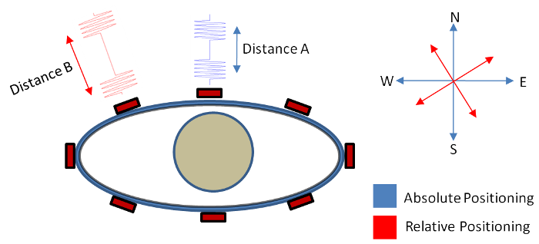
Figure 5: Application of haptic belt as a navigational aid.

Interpersonal Social Communication
At the intersection of research areas in social interaction, and that of human machine interfaces, lies the relatively unexplored field of interpersonal social communication technologies [18]. Affective Computing [19] has been exploring various sensor and actuator technology solutions toward better communication of social interpersonal signals with non-verbal communication cues [20]. With the human body having the largest sensory and perceptive surface, haptic displays, like our proposed vibrotactile belt, provide an opportunity toward enabling such communication of social signals. Over the last year, we’ve been working toward a wearable system capable of communicating interpersonal positions of interaction partners to someone who is visually impaired. In [6][7], we developed an assistive technology that is capable of determining, and conveying through a haptic belt, the interpersonal distance and orientation of an individual who is standing in front of a user who is blind. Computer vision techniques are used to extract the interpersonal distance and orientation with respect to the user. The relative direction and distance of an interaction partner is conveyed through the location and rhythm, respectively, of a vibration around the user’s waist.

Generic Information Communication
Given proper functionality, specifically expressiveness, haptic belts can be used to convey generic information through tactile icons [21], or tactons. Tactons are abstract, tactile messages, where meaning is mapped to the dimensions of the vibrations. Research has shown users’ ability to quickly learn and interpret tactons [22]. For example, [5] demonstrated that anesthesiologists have enhanced situational awareness toward adverse medical events when a haptic belt is used to monitor a patient’s physiological data in the operating room. Similarly, a haptic belt can be used to reduce visual and auditory cognitive load in military personnel [3], especially pilots and dismounted soldiers within a combat zone. A haptic belt could be used to communicate battlefield situational awareness when combined with military intelligence information and radio technology. Likewise, situational awareness, spatial orientation and navigational information can be combined to provide real time location information through a haptic belt to emergency responders who have entered a low visibility and hazardous environment where visual and auditory modalities are overloaded with information.

conclusion and future work
This paper presented a novel haptic belt design inspired by functionality, performance and usability design requirements. In contrast to other technology-centric designs, we took a pragmatic, human-centric approach to design a versatile, practical haptic belt. Although our user study is preliminary, participant feedback was very positive. As part of future work, we will conduct a more formal usability study, and evaluate the usability of the software, both the firmware and the graphical user interface, for reconfiguring the belt and building spatio-temporal patterns. Moreover, we are currently building wireless vibration motors in a smaller form factor and investigating wireless mesh network technologies. Our aim is to extend our design requirements for haptic belts, as outlined here, to any vibrotactile display. Wearables, such as vibrotactile jackets, vests and suits, are limited by many of the same performance and usability issues of haptic belts. We feel that wireless mesh networked vibration motors will help pave the way for usable vibrotactile wearables of the near future. Finally, we want to inspire the community to come together to share their hardware and software designs so we can begin to build reusable and extensible haptic platforms. To this end, we look forward to releasing to the community the components we’ve developed. We are also looking into ways we can integrate our project with editors for designing vibrotactile patterns such as posVibEditor [23] and Immersion's TouchSense SDK.

References
- K. Tsukada, M. Yasumura, “ActiveBelt: belt-type wearable tactile display for directional navigation,” UbiComp 2004: Ubiquitous Computing, 384-399, 2004.
- J.B.F.V. Erp, H.A.H.C.V. Veen, C. Jansen, T. Dobbins, “Waypoint navigation with a vibrotactile waist belt,” ACM Transactions on Applied Perception, vol. 2, 106-117, 2005.
- H.A.H.C.V. Veen, J.B.F.V. Erp, “Tactile information presentation in the cockpit,” Haptic Human-Computer Interaction, 174-181, 2001.
- feelSpace project, The Magnetic Perception Group, http://feelspace.cogsci.uni-osnabrueck.de/en/technology_01.html
- P. Barralon, G. Ng, G. Dumont, S.K.W. Schwarz, M. Ansermino, “Development and evaluation of multidimensional tactons for a wearable tactile display,” In Proceedings of the 9th International Conference on Human Computer Interaction with Mobile Devices and Services, 186-189, 2007.
- T. McDaniel, S. Krishna, V. Balasubramanian, D. Colbry, S. Panchanathan, “Using a haptic belt to convey non-verbal communication cues during social interactions to individuals who are blind,” In Proceedings of IEEE International Workshop on Haptic Audio Visual Environments and Games, 13-18, 2008.
- T.L. McDaniel, S. Krishna, D. Colbry, S. Panchanathan, “Using tactile rhythm to convey interpersonal distances to individuals who are blind,” In Proceedings of the 27th International Conference Extended Abstracts on Human Factors in Computing Systems, 4669-4674, 2009.
- R.W. Cholewiak, J.C. Brill, A. Schwab, “Vibrotactile localization on the abdomen: effects of place and space,” Perception and Psychophysics, vol. 66, 970-987, 2004.
- S. Panchanathan, N.C. Krishnan, S. Krishna, T. McDaniel, V. Balasubramanian, “Enriched human-centered multimedia computing through inspirations from disabilities and deficit-centered computing solutions,” In Proceedings of the 3rd ACM International Workshop on Human-Centered Computing, 35-42, 2008.
- R. Lindeman, Y. Yanagida, H. Noma, K. Hosaka, “Wearable vibrotactile systems for virtual contact and information display,” Virtual Reality, vol. 9, 203-213, 2006.
- J.B.F.V. Erp, “Guidelines for the use of vibro-tactile displays in human computer interaction,” In Proceedings of Eurohaptics, 18-22, 2002.
- W. Heuten, N. Henze, S. Boll, M. Pielot, “Tactile wayfinder: a non-visual support system for wayfinding,” In Proceedings of the 5th Nordic Conference on Human-Computer Interaction: Building Bridges, 172-181, 2008.
- L. Jones, K. Ray, “Localization and pattern recognition with tactile displays,” In the Proceedings of the Symposium on Haptic Interfaces for Virtual Environment and Teleoperator Systems, 33-39, 2008.
- A. Ferscha, B. Emsenhuber, A. Riener, C. Holzmann, M. Hechinger, D. Hochreiter, M. Franz, A. Zeidler, M.D.S. Rocha, C. Klein, “Vibro-tactile space awareness,” Video paper, In Adjunct Proceedings of the 10th International Conference on Ubiquitous Computing, 2008.
- R. Lindeman, J. Sibert, C. Lathan, and J. Vice, “The design and deployment of a wearable vibrotactile feedback system,” In Proceedings of the 8th International Symposium on Wearable Computers, 56-59, 2004.
- A. Rupert, “An instrumentation solution for reducing spatial disorientation mishaps,” IEEE Engineering in Medicine and Biology Magazine, vol. 19, 71-80, 2000.
- J.B.F.V. Erp, H.A.H.C.V. Veen, “A multi-purpose tactile vest for astronauts in the international space station,” In Proceedings of Eurohaptics 2003.
- N. Kock, J. Nosek, “Expanding the boundaries of e-collaboration,” IEEE Transactions on Professional Communication, vol. 48, 1-9, 2005.
- R.W. Picard, Affecting Computing, The MIT Press, 2000.
- S. Krishna, D. Colbry, J. Black, V. Balasubramanian, S. Panchanathan, “A systematic requirements analysis and development of an assistive device to enhance the social interaction of people who are blind or visually impaired,” Marseille, France, 2008.
- S. Brewster, L.M. Brown, “Tactons: structured tactile messages for non-visual information display,” In Proceedings of the 5th Conference on Australasian User Interface,vol 28, 15-23, 2004.
- L. Brown, S. Brewster, H. Purchase, “A first investigation into the effectiveness of Tactons,” In the Proceedings of the First Joint Eurohaptics Conference and Symposium on Haptic Interfaces for Virtual Environment and Teleoperator Systems, World Haptics 2005, 167-176, 2005.
- J. Ryu, S. Choi, “posVibEditor: graphical authoring tool of vibrotactile patterns,” In the Proceedings of the IEEE International Workshop on Haptic Audio Visual Environments and Games, 120-125, 2008.

